**Urban Agenda Partnership on Innovative and Responsible Public Procurement for EU**

**Meeting on April 10th and 11th, 2024**

*Location****: City Hall Haarlem, Raadzaal,*** *Grote Markt 2, Haarlem (12 minutes walking from the Central Train Station of Haarlem)*

**Wednesday April 10**

*08:30-09:00    Welcome with coffee/tea*

09:00-09:15 Kick off: Welcome, agenda and goals by UA Coordinator Valentina Schippers-Opejko

09:15-09:30    Update on the EU funded project ‘LIFE: Future Proof Sports Pitches’ by (tbd)

09:30-09:45 Update on the EU funded project ‘PROCEDIN’ by Louise Knight (University of Twente)

09:45-10:00 Presentation (tbd)

*10:00-10:15 Coffee/tea break*

10:15-12:30   Action Group 1:

*10:15-10:30* 1. Presentation and Launch of the Urban Agenda Public Procurement Platform by José Navarro Gavilán and Conxita Francisco Brumos (Barcelona Provincial Council)

*10:30-11:45* 2. Position Paper ‘Advocacy opportunities for the UA Partnership’

*11:45-12:00* 3. Decision about the expansion of the UA E-learning module with different languages (which ones?)



*12:00-12:50 Lunch*

12:50-13:10 Action Group 3:

Examples of Partners using Public Procurement to realise Economic Regeneration by Matthew Baqueriza-Jackson (URBACT)

13:10-14:00 Presentation ‘Measuring Impact of Spend by using data-oriented procurement tools’ by Stefan Rigter and Judith Strik (Municipality of Amsterdam)

14:00-15:00 **PROCEDIN Legal Framework Training:**

 **‘Award Below Threshold & Total Cost of Ownership’**

*15:00-15:20 Coffee/tea break*

15:20-16:20 **PROCEDIN Legal Framework Training:**

**‘Functional Specification & Human Centred Design‘**

16:20-16:50 Presentation (tbd)

16:50-17:00 Sum-up and agenda for tomorrow

18:00-21:00 Evening program April 10: informal dinner at Restaurant De Roemer, Botermarkt 17, Haarlem

……………..xxxxxxxxxxx………………

**Thursday April 11**

*08.45-09.00 Welcome with coffee/tea*

09:00-09:05 Welcome and start of the day by Valentina Schippers-Opejko

09:05-09:20 Update on the EU funded project ‘PROTECT’ by Marc Pattinson (GAC)

09:20-09:30 Update on Urban Agenda by Dutch Envoy Karen van Dantzig

09:30-12:15 Action Group 2:

*09:30-10:45* 1. Contract Management expert briefings:

Presentation by Mariska van Dalen, founder [Sustainable Procurement Platform](https://sustainableprocurementplatform.eu/)

 Presentation by (tbd)

*10:45-11:00* *Coffee/tea break*

*11:00-12:15* 2. PROCEDIN Workshop ‘How public authorities can make use of knowledge and work from European students’ by Louise Knight (University of Twente)

12:15-12:30 Plenary sum-up of the Action Group sessions day 1 and day 2, conclusions & sum up by Valentina Schippers-Opejko



12:30-13:30 Lunch or packed-lunch-to-go

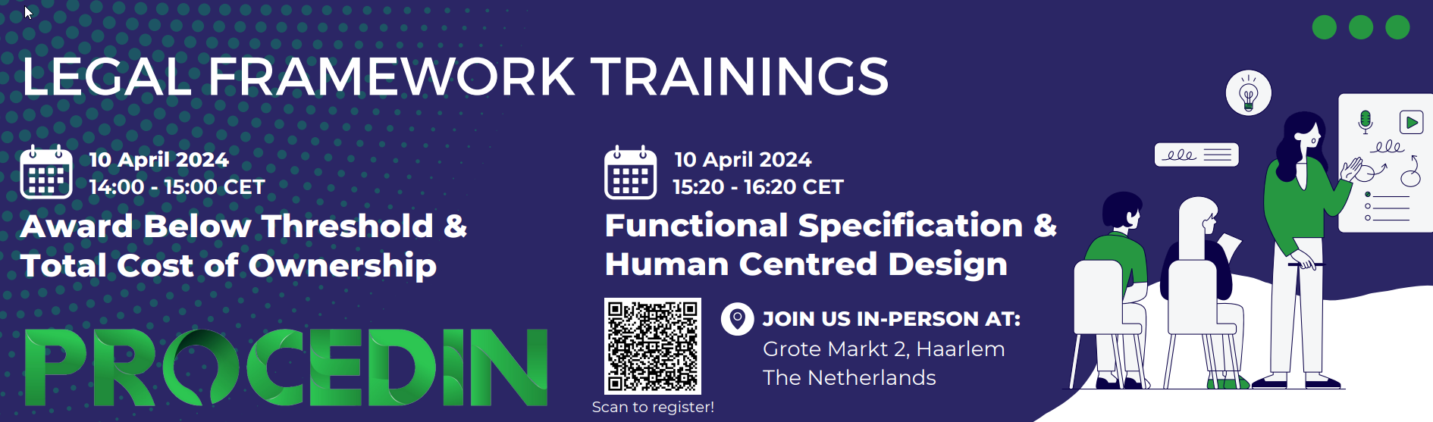

You can already register for these trainings here:

[Registration Form LF trainings April 10 & 11, 2024](https://docs.google.com/forms/d/e/1FAIpQLSc1ZLgMBjgETNT2wm--s-qlsd1jOkfPK18oEUI--8xotTFetw/viewform?usp=sf_link)

**OPTIONAL: 13:30-16:30 Extra time for Action Groups to work together**